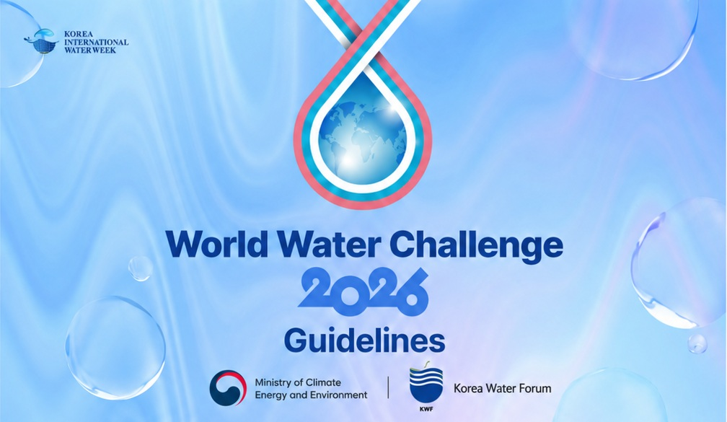

Contents

1. OVERVIEW ------------------------------------------------------------------------- 1

2. BENEFITS ------------------------------------------------------------------------- 1

3. ELIGIBILITY ------------------------------------------------------------------------- 2

4. PROCESS -------------------------------------------------------------------------- 2
A. APPLICATION ---------------------------------------------- 2
B. OBJECTIVES ---------------------------------------------- 3
C. EVALUATION CRITERIA FOR SOLUTIONS ------------------- 4

1. OVERVIEW
The World Water Challenge is an international contest hosted by the Ministry of Environment of Korea and organized by Korea Water Forum for water solutions. It was created as a special program of the Science and Technology Process in the 7th World Water Forum to identify imminent global water issues and to find feasible solutions based on the core value of “Implementation”.

Attracting great attention in the 1st edition in 2015 at the 7th World Water Forum, the program has become one of the symbolic platforms of implementation which has been followed up in the Korea International Water Week (KIWW).

World Water Challenge 2026is expected to serve its role as an important platform to share not only innovative scientific/ technological methods but also policies towards solving specified water problems around the world and to build a broad network among experts and stakeholders in the water sector as well as solution providers.

2. BENEFITS
Up to 10 selected solution providers will be invited to the final round of the WWCH in Daegu, Korea. The final presentation and award ceremony will be held on Sep10-11th during the KIWW 2026. ‘THE BEST’ prize winner will have a chance to speak at the WWCH 2027 the following year.

*Airfare for the round-trip and accommodation will be partially subsidized for the finalists.
(The dates of travel and accommodation MUST align with WWCH 2026, any travel plans extended for personal reasons will not be covered by the Secretariat)

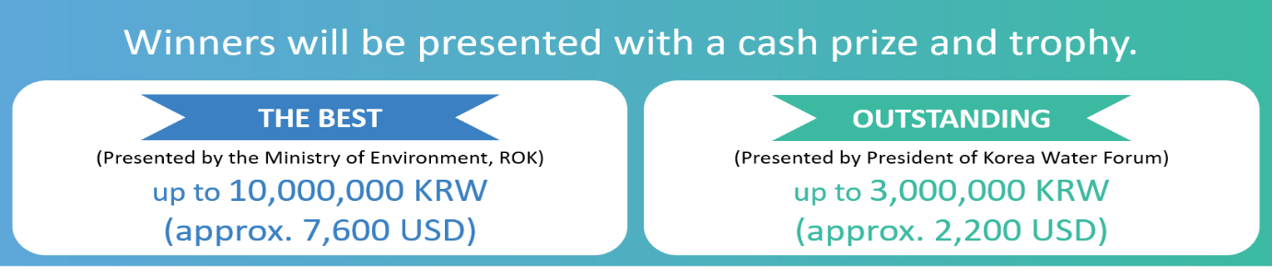

- One recipient of ‘THE BEST’ award and two recipients of ‘OUTSTANDING’ award will be selected.
- The title of the awards and the amount of prize money are subject to change.
- If there is no qualified solution for the “THE BEST” prize based on the decision of the evaluation committee, there may not be a winner of the year and/or type of award and prize money may change.
3. ELIGIBILITY
Anyone (as an individual or on behalf of an organization) who is interested in contributing to resolving water-related challenges with creative/applicable solutions is welcome to submit solutions to WWCH 2026’s designated categories.

* Persons (including winners) who participated once (and more) in the previous WWCH are allowed to participate in the WWCH 2026 with different (or updated) subjects and ideas. (Same contents or ideas with the previous contents, will not be considered.)

4. PROCESS
Solution Submission
Final Presentation
Solution Selection
(June 1st -July 12)
(Aug 3)
(Sep 11)

A. APPLICATION
The candidates are requested to submit solution proposals through the web-based system (on KIWW Official website) using the provided application form.
- All applicants are strongly encouraged to read and follow the submission instructions provided in the application template.
* The official WWCH 2026 application form can be downloaded from the KIWW website.
- Solution proposals can only be submitted via the web-based system. E-mail submission will not be considered.
* To submit a proposal, applicants must first create an account via the website’s sign-up page.
- Solution proposals must be filled out only in English.
- A graphical abstract visually summarizing your solution (e.g., schematic diagram, picture, animation, etc.) should be submitted as a separate file.
- One person (or organization) can submit more than one proposal with different solutions.
- Please note that all materials submitted for entry will not be returned and they might be used or published partially or wholly by the secretariat.

Solution Submissions: Due by July 12, 2026 24:00 (KST)

B. OBJECTIVES
World Water Challenge 2026 seeks innovative ideas that address local or global water-related challenges, contributing to the achievement of the United Nations' Sustainable Development Goals (SDGs).

We welcome solutions that prioritize one of the following areas.

- Water-Energy-AI Nexus:
[NRW, Water-Energy Nexus & Infrastructure]
- Integrated Low-Cost Non-Revenue Water Reduction and Energy-Efficient Operation System for Urban Water Networks
[Energy-Generating Water Technology]
- Advancing Energy-Generating Water Technologies

- AI & Data Driven Water Security:
[Flood, Drought & Dam Safety]
- Smart Reservoir and Dam Operation System for Flood Control, Drought Preparedness, and Structural Safety of Aging Dams
[Water Quality & Urban Water Security & AI]
- Deep Learning-Based Prediction · Source-Tracing · Response Technology for Urban Water Quality Security
[Smart Stormwater Inlet System for Flood Response]

- Sustainable Infrastructure & Climate Finance:
[Sewerage & Finance]
- Developing Financing Solutions for the Modernization of Aging Sewage Treatment Plants for Sustainable Cities

C. EVALUATION CRITERIA for SOLUTIONS

Evaluation Items | Detailed Contents of Evaluation | Score
Fact-finding | - If the solution provider exactly understands the  problem including background, objectives, scope,  cause and effect, and impact on the global water  issues. | 5
Contribution to “Sustainability” | - If the solution addresses the environmental, social and economic impacts of the solution, both in the short and long term.  - If the solution has the potential for long-term sustainability, ensuring it remains effective and relevant over time. | 25
Feasibility | - If the solution is realistic and achievable given available resources, infrastructure, and context  - If the solution is realistic and practical in terms of deployment, considering available infrastructure, financial resources and technical capabilities | 30
Originality / Novelty | - If the solution presents a new, creative approach or a unique application of existing technologies.  - If the solution challenge conventional thinking and push the boundaries of current water resilience and efficiency practices. | 25
Impact | - If the effects of activities in solving water challenges are obviously described. | 15
Each submission will be judged based on five different criteria as below and can earn a maximum of 100 points. At most, 10 finalists will be selected and the final presentations will be also evaluated by the committee during KIWW 2025.

